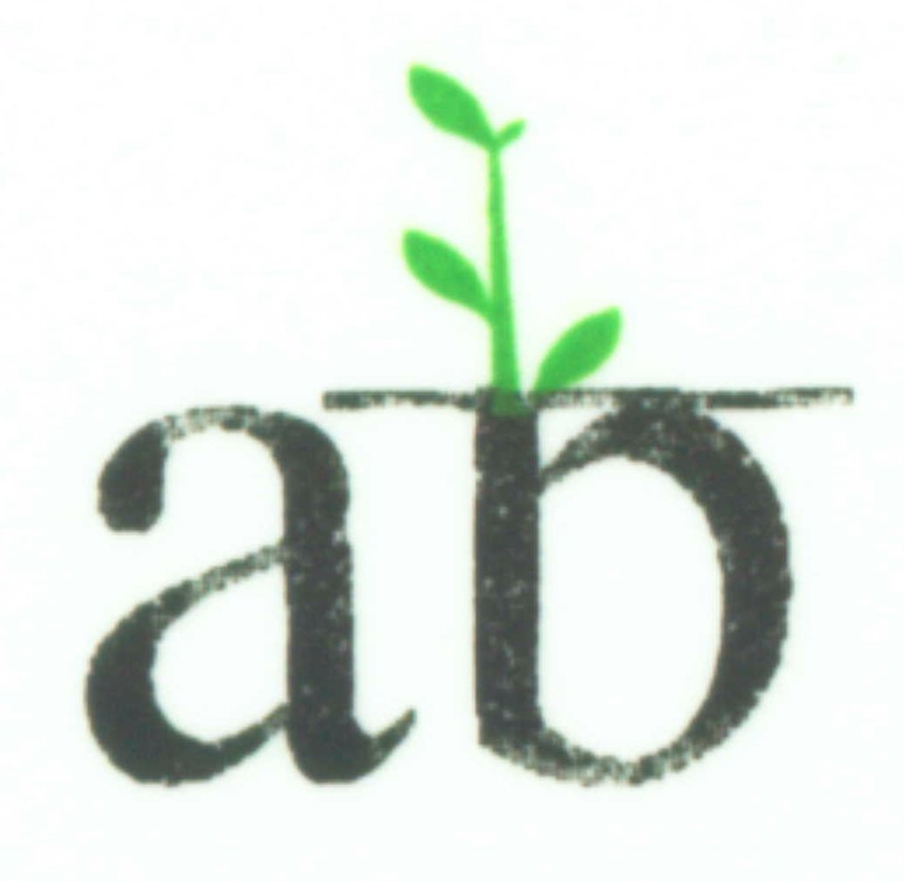
Ab- Initio

Questionnaire for Green Building Design

Company Profile:
Name of the Company | :
Contact Person & Designation | :
Address | :
Phone No | : | Cell No :
Fax No | : | Email :

- Please select your category for LEED certification:
  - LEED New Construction
  - LEED Core and Shell
  - LEED Existing Building
  - LEED Commercial Interior
  - IGBC Green Home

- Which level of LEED rating would be desired, choose from following:
- LEED certified Platinum level
- LEED certified Gold level
- LEED certified Silver level
- LEED certified level

- Location Details:

- Total Built up area-
- Whether the land comes under the CRZ? -
- Is section 80 A MOEF (requirement of Environment Impact Assessment) applicable? If yes, Details.-
- Minimum development density per acre? –

Availability of 10 basic services?

Public transportation access?

- Please furnish Architectural Drawing and Plot plan

- Is proposed Material of construction finalized? If yes, please furnish the details

- Does site have adequate water availability?

- Is Rain water harvesting considered at the facility?

- Is STP and water recycling considered?

- HVAC system:
- Segregation of conditioned and unconditioned areas:
- No of persons working and working nature of building?
- What is the equipment density? Please provide details if available-
- Other technical detailing available?

- Is lighting requirement for individual areas finalized? If yes, furnish details of lighting –

